SPATH QES TE SLILK’YAP — Word List Key

Halq’eméylem | English | reference: Galloway
el swà | my own | 448
éltha (áltha) | it is me (emphatic “I”) | Tomels 28
hélem | he’s been made to go | 204
í:mex | s/he is walking
imexósem | going for a walk/taking a stroll | 119
kw’éts’lexwes | he sees it | 1515
kw’íystexwes | he raised it up | 191
létsaxw | one day (once, one time) | 1416
lhe'á | go by way of/via | 273
qelát | again | 436
q’ál | go around (an obstacle) | 462
q’eq’xótel | arguing back and forth | 479/1179
qwélqwelíwel | s/he is thinking about it (lit: talking it over inside) | 504
selóthel (semlóthel) | the other side/edge | 359
slilk’yáp | (little) coyote | 216
spá:th | bear | 65
ste’á:wel | making a guess/wondering | 624
stl’ep’él:ets | tail | 1591/634
stl’èpíqel | bank | 817
sth’epeq/ s’ép’ek | skunk | 1537/649
tél:exw | he learns it/ he learned it | 676
tútl’ò | he / him | 495
thét | say/ he said | 751/752
tl'eláxw | stay/ be in a place | 814
tl’élexw | stop/ he stopped | 814
tselíl | maybe | 1377
xálh | road / trail | 899
xwchómes | they were meeting | 47
xwe’áyem (yetha) | between them | 87/1156
xwe’i:t | what is someone doing?/ why? | 934
xwemxálèm | he ran | 1501
xwítsel | middle | 1382
xélts’thet (tútl’o) | he turned (himself) around | 964/1623
xwlalá:metes | s/he is listening
ye | going along while doing something | 1026
yewá:l | first | 1042

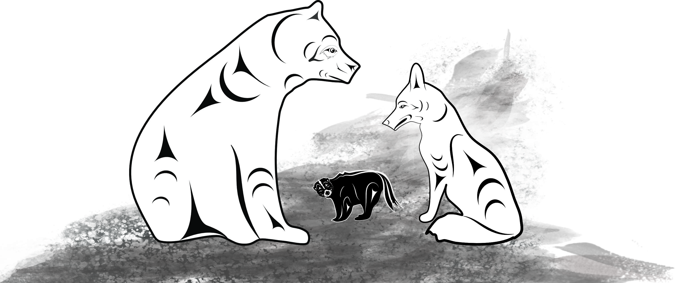
*(there is another ‘ye’ which means plural ‘the’, e.g. ye spá:th – the bears)

