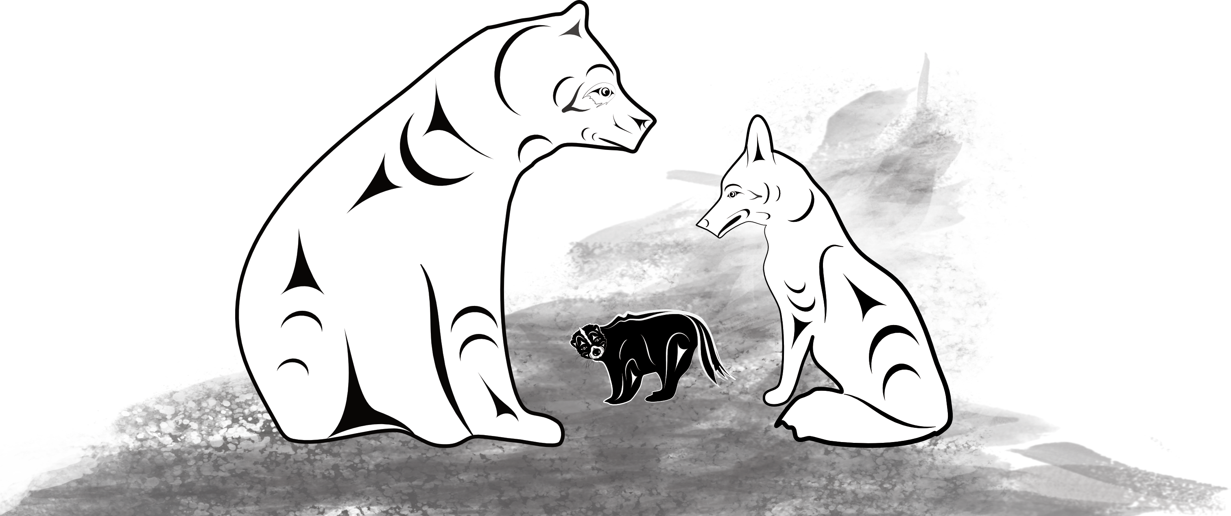
Bear and Coyote as a Play

Narrator:

One day bear was walking down the road. Coming towards him was coyote. Coyote was also going for a walk down the road. When they met each other, they stopped. Bear spoke first, he said,

Bear:

“Hello, I’m bear, and this is my road.”

Narrator:

Coyote did not agree. He said,

Coyote:

“I’m coyote, and this is my road.”

Narrator:

They started arguing about it.

Narrator:

Bear said,

Bear:

“I’m bear and this is my road.”

Narrator:

Coyote said,

Coyote:

“I’m coyote and this is my road.”

Narrator:

Skunk was down the bank listening to bear and coyote. He wondered what was going on so he went up to see. Skunk said,

Skunk:

“What are you doing?”

Narrator:

Bear said,

Bear:

“I am bear, and this is my road.”

Narrator:

Coyote said,

Coyote:

“I am coyote, and this is my road.”

Narrator:

Skunk thought for a while. He walked between them to the other side of the road. He stopped. He turned around, put his tail up, and walked between them again. Bear saw skunk’s tail, turned and ran down the road. When coyote saw skunk’s tail, he ran the other way.
Skunk stood in the middle of the road and said,

Skunk:

“I AM SKUNK, AND THIS IS MY ROAD.”

Story resource: Coqualeetza Cultural Education Centre

